July
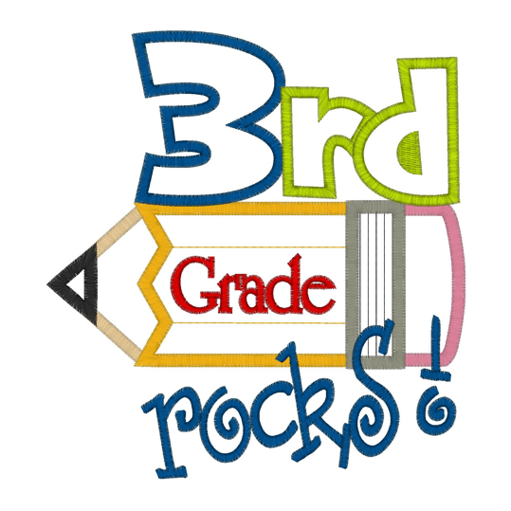  Hello 5th Grade Explorer Parents!  Class Dojo  Parents, please be sure to connect to our classrooms via Classroom Dojo. Dojo allows for messages to be sent quickly during the day and for teachers to give updates to parents nightly. We are always posting pictures and the going ons of what is happening in our classroom daily to keep you informed on what we are learning. Dojo also allows you to see your child’s behavior in the classroom both positive and negative in real time, along with consequences and allow open communication between you and the teacher.  Friday Folders  Be on the lookout every Friday! On Fridays students will take home their Friday Folders. Please check these folders every weekend to see samples of student work, important notes and notices going on in the classroom and here at East Garner, as well as papers that may need to be returned to school. Student folders should come back to school on Monday empty, unless individual papers require to be returned to school signed.  Classroom Website  Our grade level has a website. Please follow the link below to have access to curriculum, tools, and websites we are using in the classroom to reinforce learning. You can also find important documents, newsletters, schedules, contact information, and many other resources to help your student at home.  https://eges-5thgrade.weebly.com/ | Important Dates  August 16 OPEN HOUSE 6:00-7:00  August 17 Early Release  September 3 Holiday: No School  September 17-21 Spirit Week  September 21 End of 1st Q: REPORT CARDS GO HOME  September 24 Teacher Workday  September 25 Teacher Workday  September 26-Oct. 5 Track Out
Curriculum

Language Arts: We will begin the year learning about human rights through the text Esperanza Rising. Students will connect the text to articles in the Universal Declaration of Human Rights as they dissect story structure, main idea, and summary. Students will also use their knowledge of the text and experiences to create inferences.

Math: Students begin the year with a unit on graphing and data. Students will gather and represent data with a variety of graphs.

Science: Students will start the year with a unit on the Human Body and its many systems that work to keep the body functional as a whole.

Contact

Address
5545 Jones Sausage Rd, Garner, NC 27529

Phone
(919) 773-7411

Email
Mrs. Perez - lperez@wcpss.net
Mr. Cassady - wcassady@wcpss.net
Ms. Taylor - ltaylor9@wcpss.net
Mr. Griffin - fgriffin@wcpss.net
Mr. Della Rosa jdellarosa@wcpss.net

